**Deployment Manual of Galaxy**

1. **Deploy DB**
2. Download code
3. Open VS 2010
4. choose Team Explorer and click Connect to Team Project

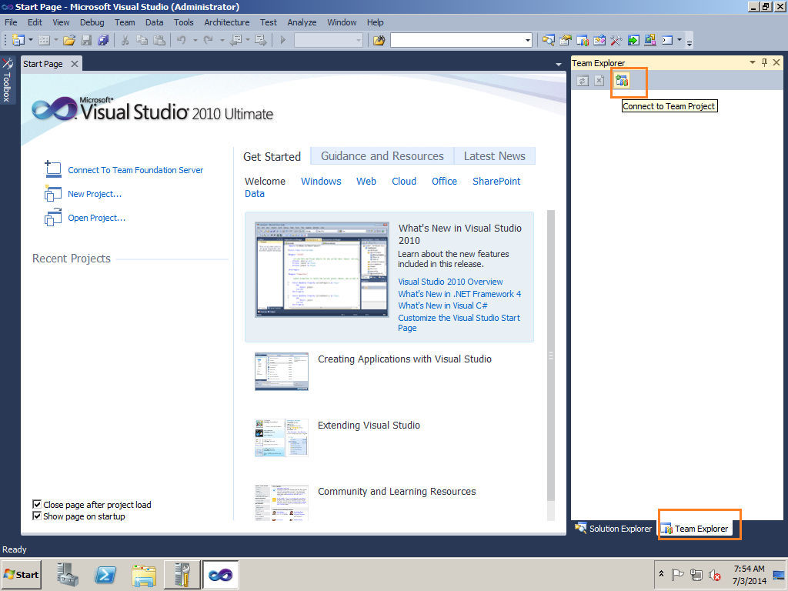

1. Click the Server and Input the server IP

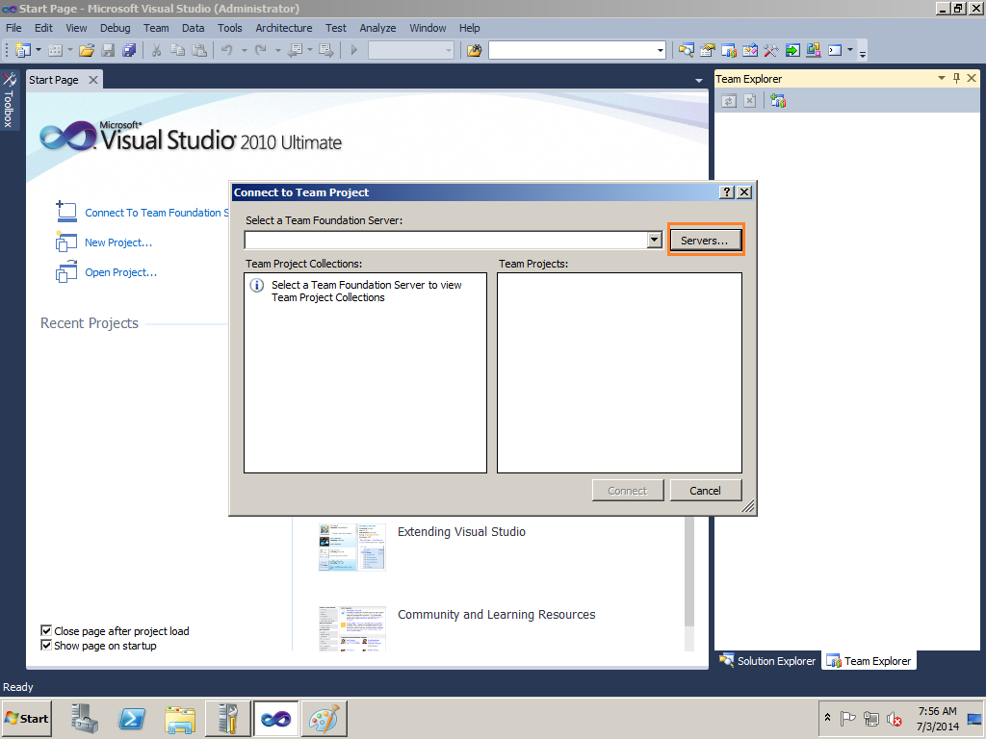

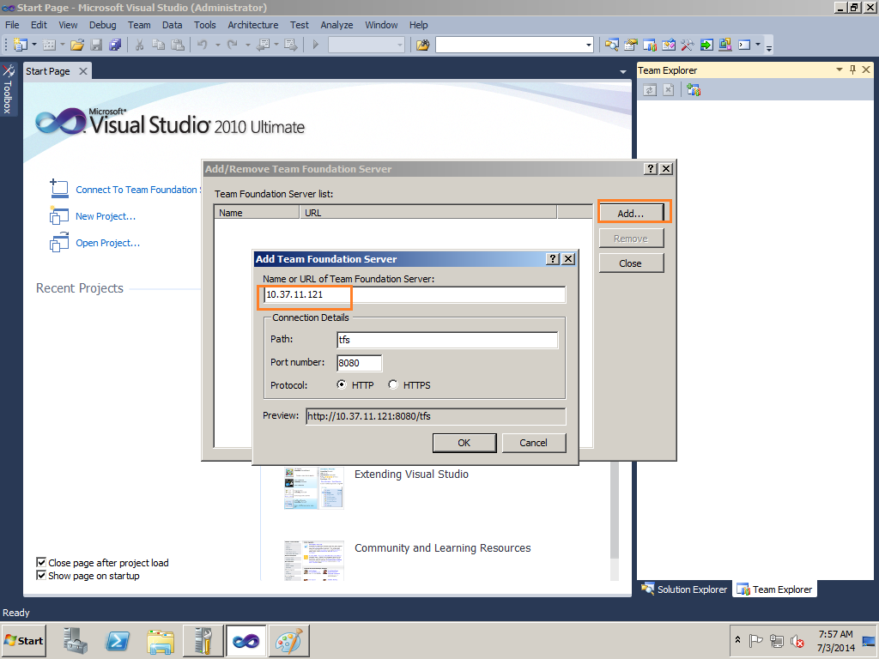

1. Double Click Source Control and Choose the Project you want to download.

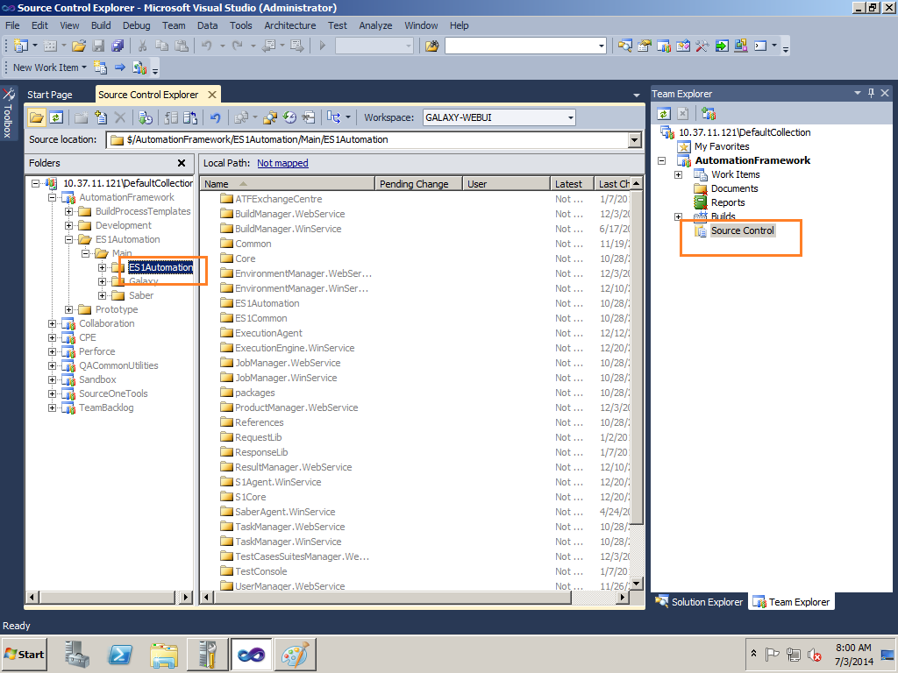

1. Because our environment uses the same server template, so sometimes it cannot download code if you have already downloaded code in other server. Here is the solution.
2. Right click the project and choose Get Specific Version

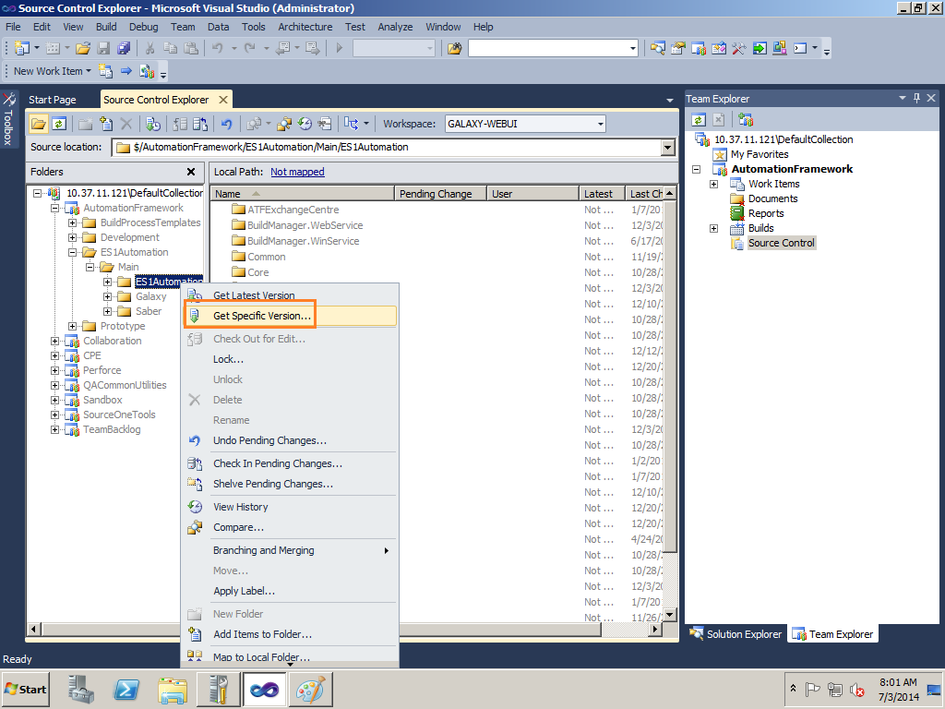

1. Check Overwrite all files even if the local version match the specific version and click Get

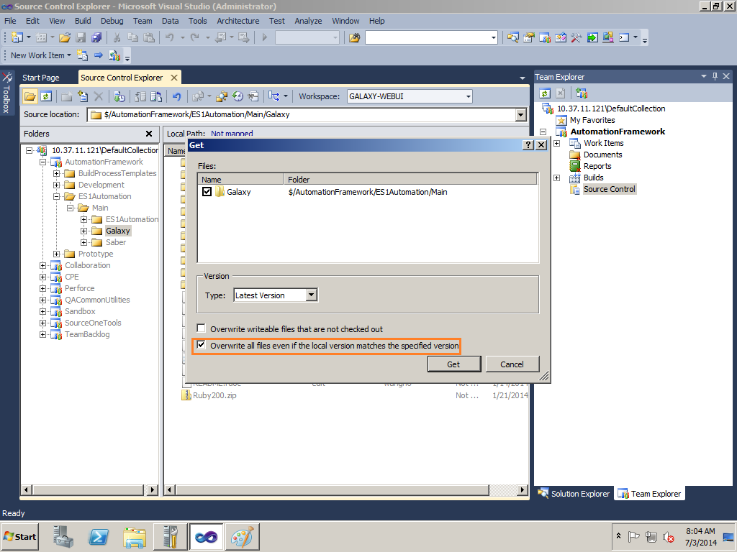

1. Open the ES1Automation.sqlproj in the directory AutomationFramework\ES1Automation\Main\ES1Automation\ESAutomation\
2. Right click this project and choose Publish. You will see this picture.

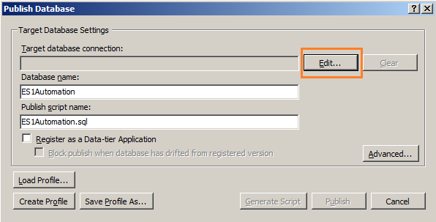

1. Click edit and input localhost

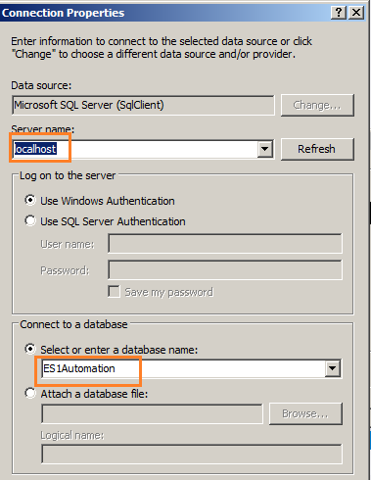

1. After publishing the project, check whether there is S1Automation in SQL Management Studio.

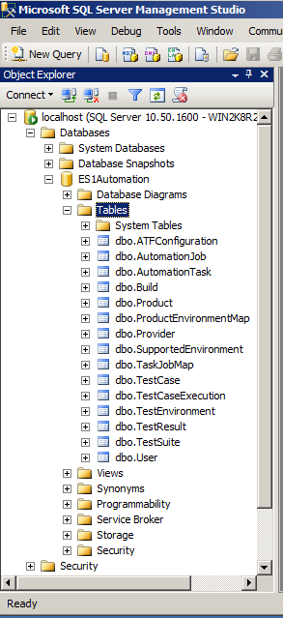

1. **WinService**
2. Download the project, reference the related steps of DB
3. Build the Project and open the win service project folder

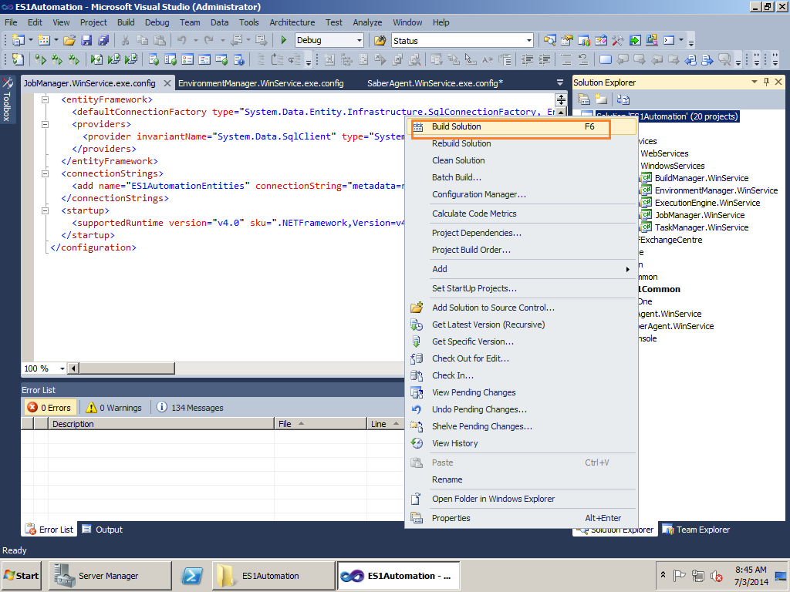

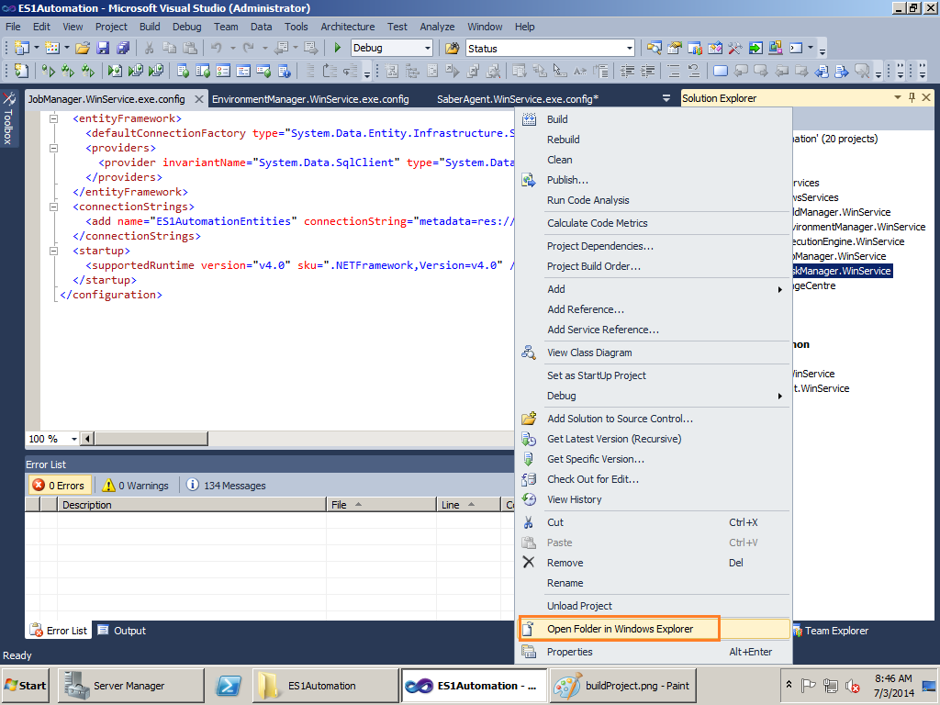

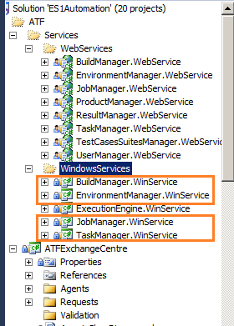

1. Change the config files in all the services. Datasource needs to change to the IP of your DB server (All service needs configuring), while Saber agent needs to change to the IP of your File Server ( EnvironmentService needs configuring ).

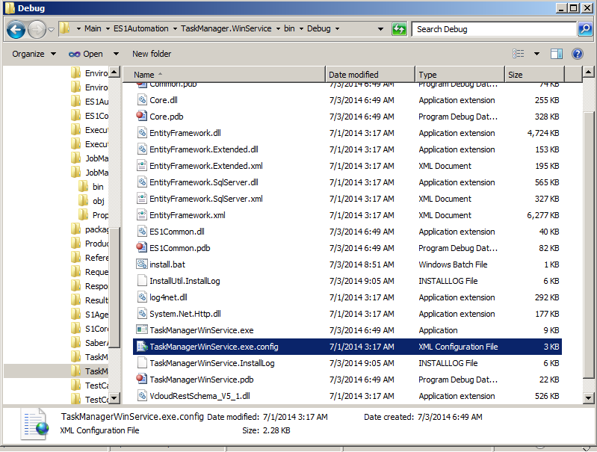

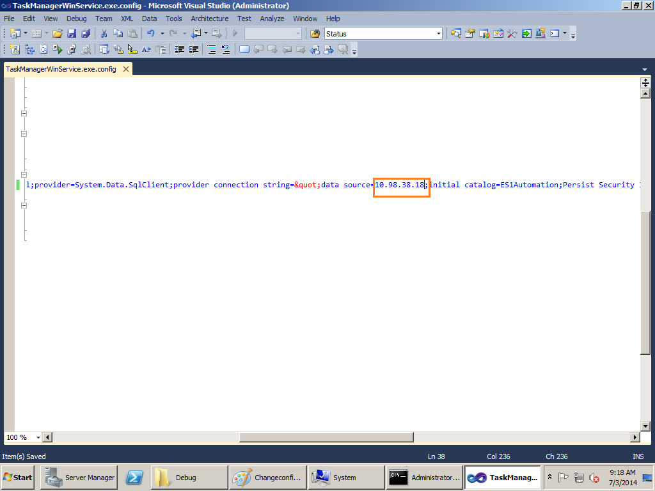

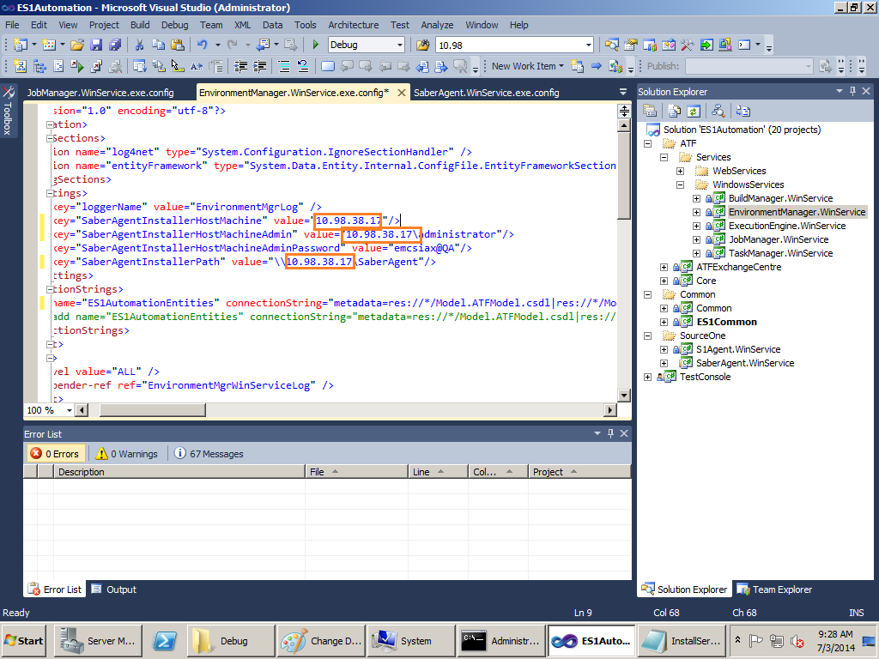

1. Edit the install.bat sometimes needing to remove the property readonly , change the path of the Project and run the scripts.
2. Input user name with computer name and password to install service.

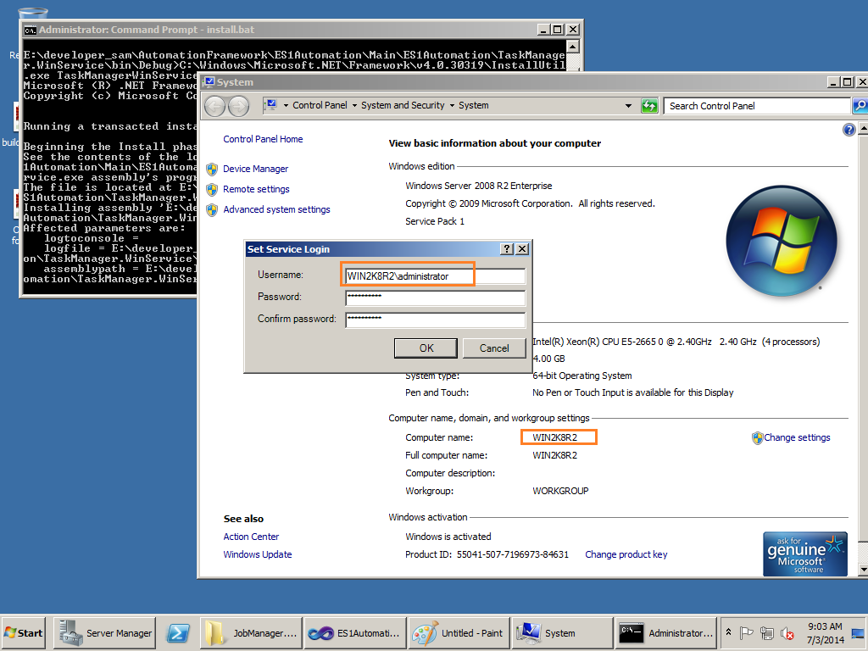

1. Check the service in the Service Manager.

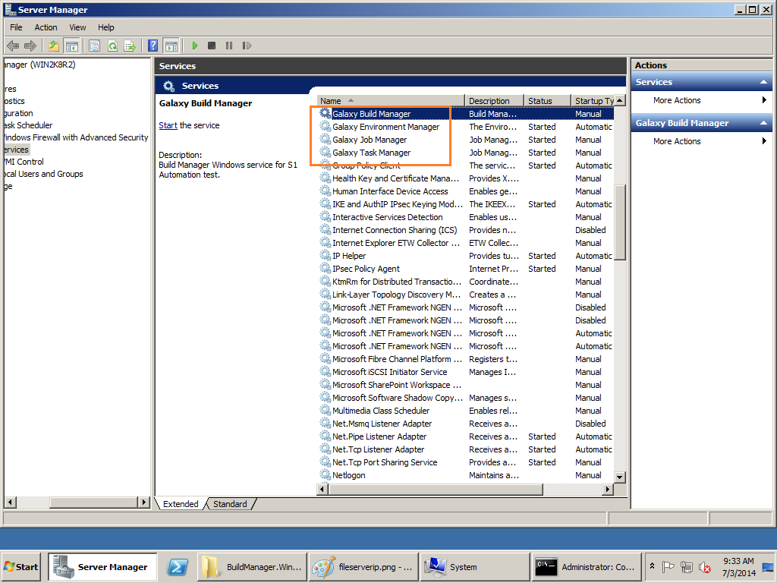

1. **WebService**
2. Download the project, reference the related steps of DB
3. Create Site and Application pool

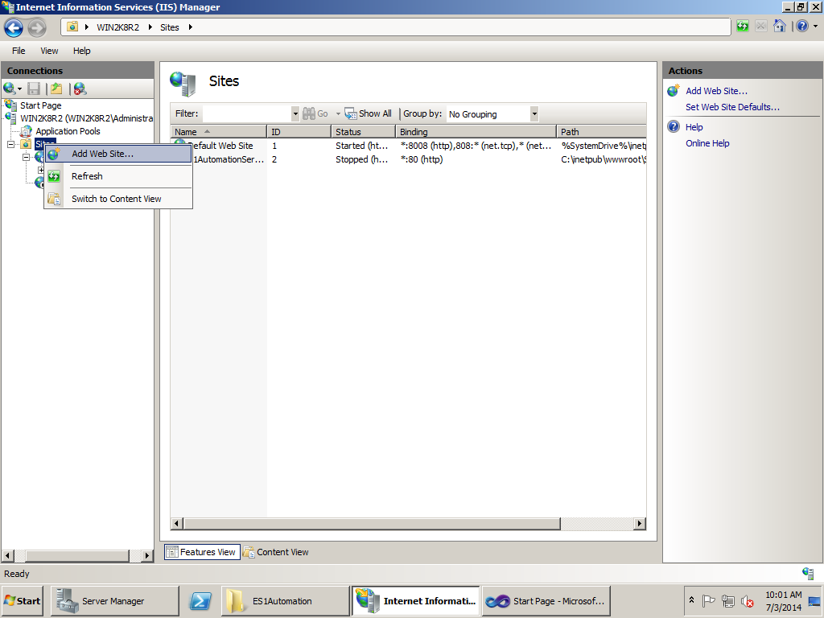

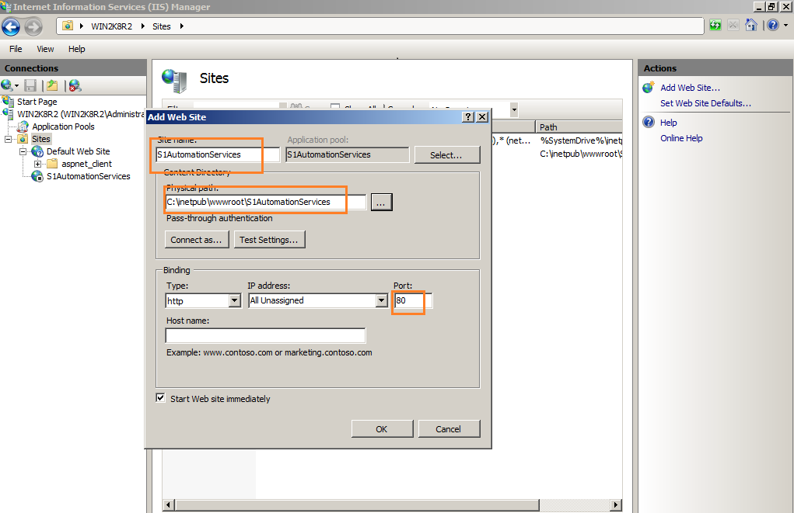

1. Publish all the projects in the WebService folder.

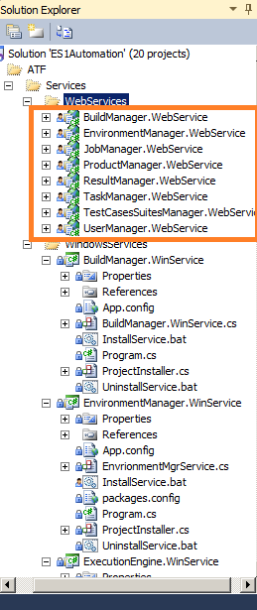

1. Move one of the Web.config from either of the application folder to the S1AutomationServices. Delete all the web.xml in each application folder. Change the connection string to the IP of your DB Server

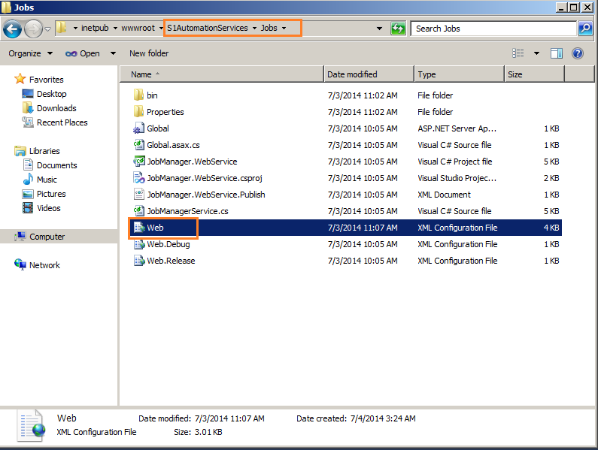

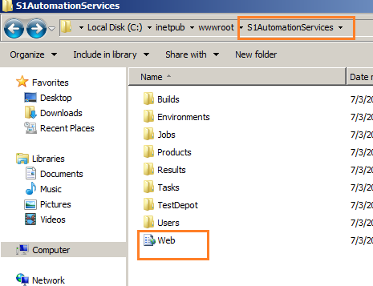

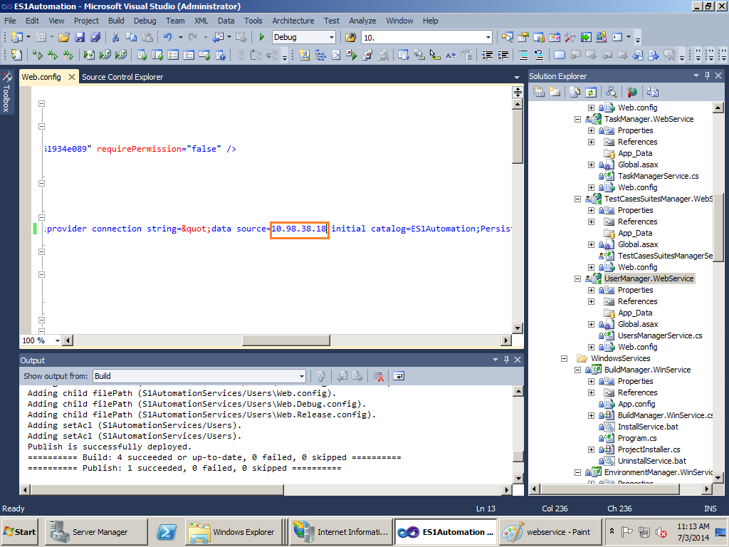

1. Change the .NET Framework version to 4.0

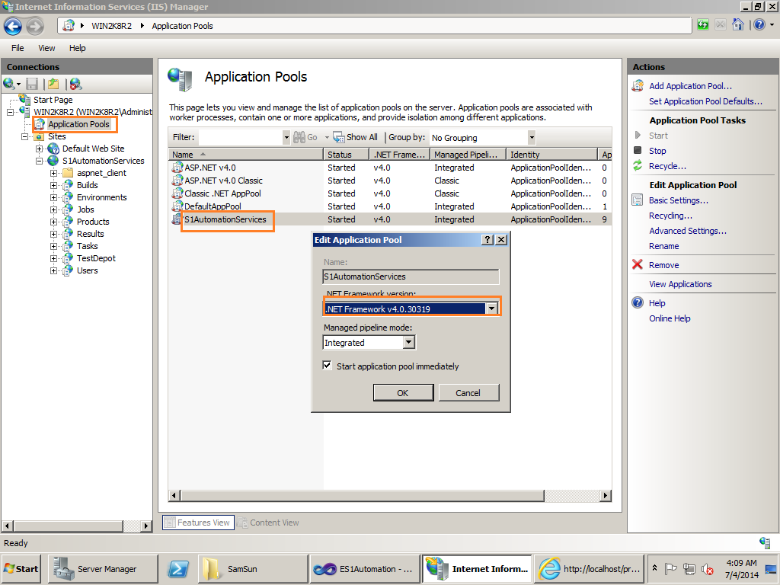

1. Check the Internet Information Service (IIS) Manager whether all the webservices have been published successfully.

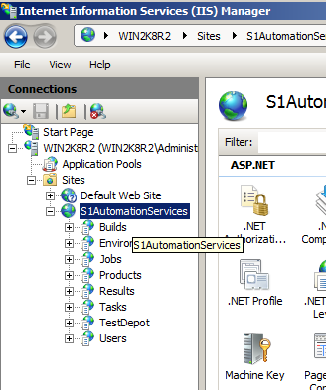

1. Start the site and Run aspnet_regiis –i under the directory .NET Framework.

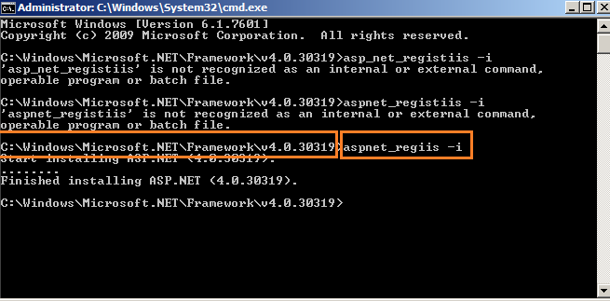

1. Input <http://localhost/products> and check the result. If you see Automation Framework0SourceOne1Supervisor2, then webservices server has been deployed successfully.
2. **FileServer**
3. Create Share folders for Saber Agent and Other server like below.

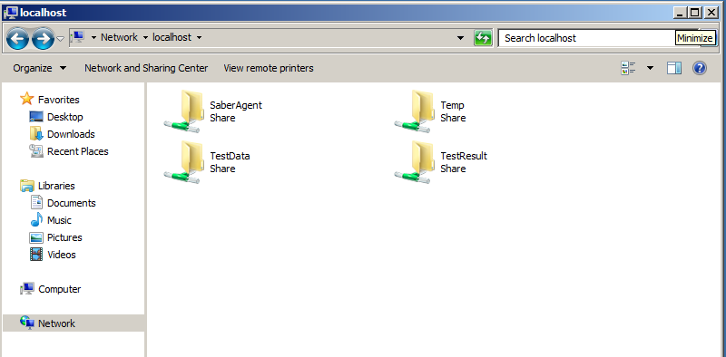

1. Copy the Saber Agent files from Wins server to the folder Saber Agent in the File Server and change the configuration file

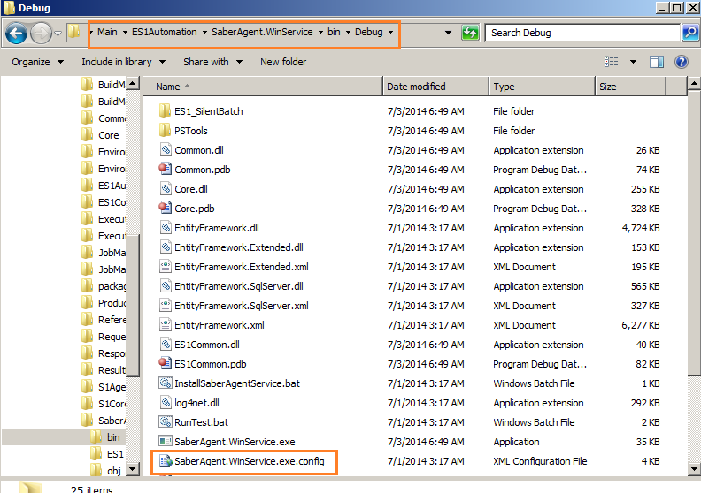

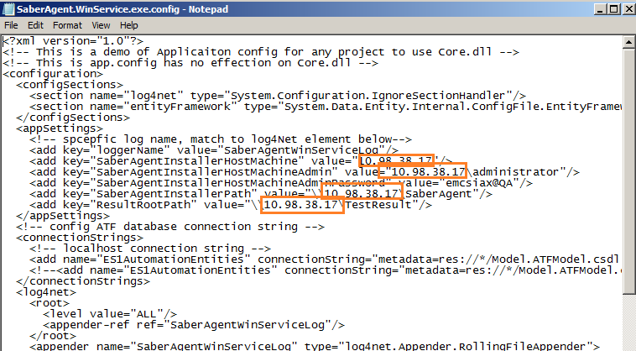

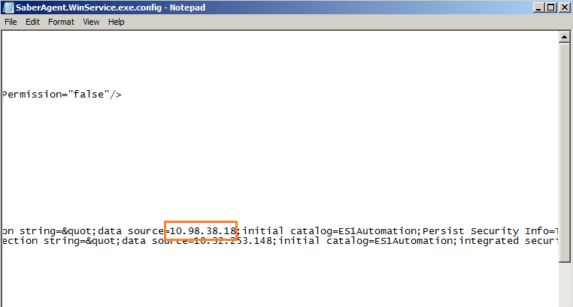

1. **WebUI**
2. Download the project to the server as the related steps above.
3. Remove the property ReadOnly of two files
   1. Galaxy\db\development.sqlite3

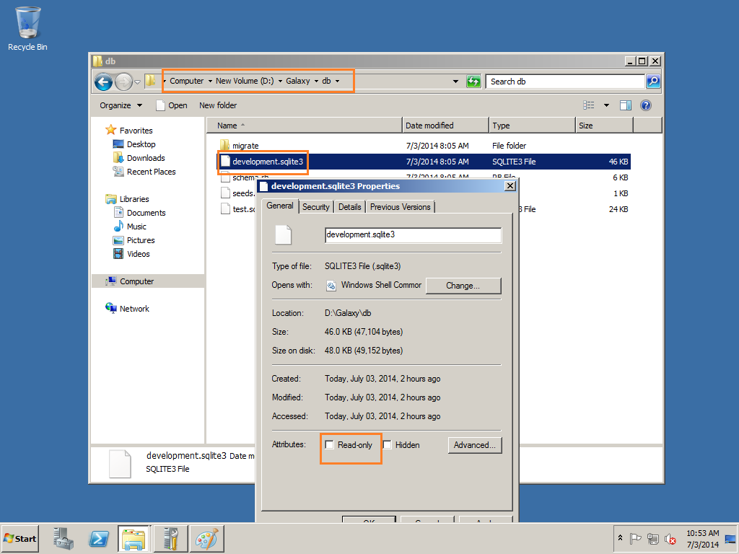

* 1. Galaxy\Config\application.rb

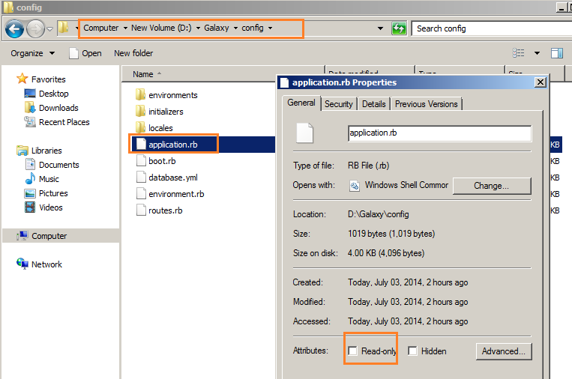

* 1. Modify the FORCE_SERVER in the file application.rb to the IP of WebS server

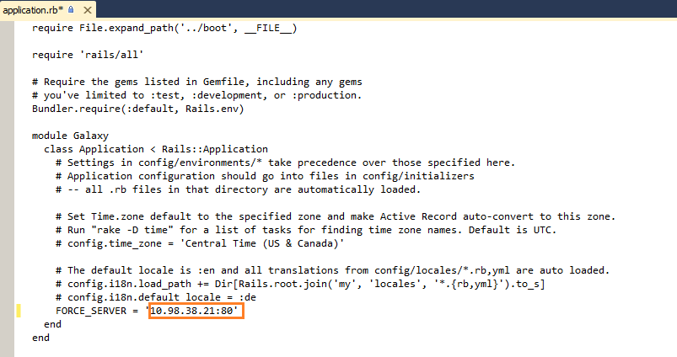

1. Run the command under the Galaxy Directory rails server –p 80
2. Input <http://localhost> in the Browser

